P r e s s R e l e a s e
September 30, 2021

hep is Awarded
hep Receives the Financial-Advisors-Award in the Category
“Sustainable Tangible Assets “

Güglingen, September 30, 2021 – hep receives the Financial-Advisors-Award 2021 in the category “Sustainable Real Assets“. The prize, which was awarded for the 19th time, is one of the most prestigious and important awards for capital investments.
Innovative, transparent, broker-oriented and investor-friendly are the criteria used by a top-class jury to select the award winners – criteria that have been an integral part of hep’s business model since the beginning.

hep is a Pioneer and Market Leader for Sustainable Tangible Investments
In the market of tangible assets, hep has been successful as a provider of closed-end investment funds on the German capital market for more than ten years. “From the beginning, our investment offer consisted exclusively of tangible assets. It only invests in solar parks that are developed, built and operated by hep. To this day, our business model is unique in Germany and has become our flagship within ten years“, say Thorsten Eitle, Chief Sales Officer of hep. “We are established in the market and are valued by sales partners, costumers and respected by competitors. Everyone knows: hep is the specialist for solar parks and solar investments.“ An important milestone in 2018 was the approval to operate as a capital management company (KVG) in accordance with the German Capital Investment Code.

hep Offers Strong Investment Offer With Multiple Awards
The current public AIF “HEP – Solar Portfolio 2 GmbH & Co. geschlossene Investment KG“ is one of the strongest investment offers in the field of alternative investment funds. Dextro ranks it with AA and risk class 3. Dextro sees the diversified, long-term and holistic fund concept as particularly positive.
In the G.U.B. analysis, the public AIF achieves the grade A+. The main arguments are the distinctive specialization in photovoltaics, the remarkable results of the previous funds and hep’s extensive experience with investments abroad.
In addition, the Scope Analysis GmbH rating company gives HEP Kapitalverwaltung AG an “A“ grade in its initial asset management rating. The Scope analysts are convinced by the company’s holistic approach, strong growth strategy, successful track record and proactive risk reduction.

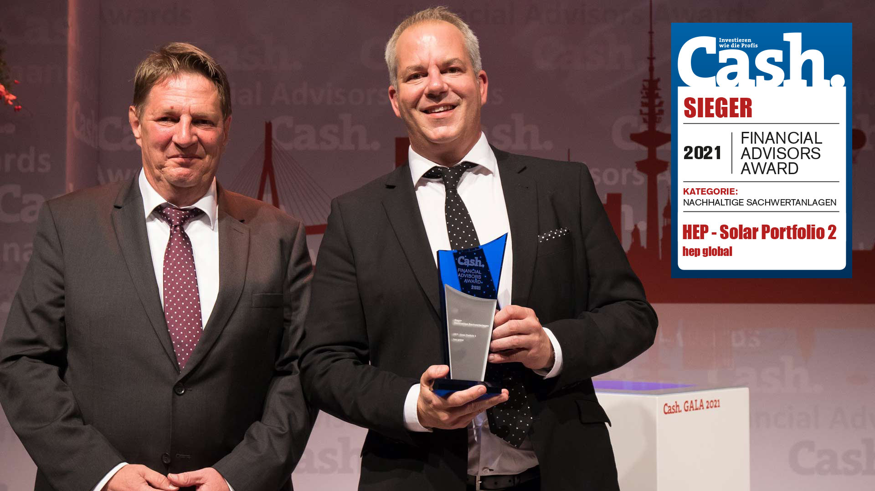

CSO Thorsten Eitle proudly accepts the FAA Award from Stefan Löwer at the Cash. GALA (credit: Florian Sonntag).

Invest Responsibly With hep
A partner for everything that is solar energy. That is hep. Since 2008, we develop, build, operate and finance solar parks. Worldwide. For energy generation that can do more than just supply electricity. The large-scale photovoltaic plants we have developed have a capacity of around 800 megawatts. With locations in Germany, Japan and the USA, we operate 16 solar projects ourselves. Our active pipeline for future projects holds a good 5,300 megawatts (as of 31.03.21).

We combine high-tech expertise with the highest level of competence in finance. This makes us unique. More than 2,000 investors, around 268 million assets under management and a successful track record: this is how we underpin our sustainable corporate success. HEP Kapitalverwaltung AG designs investment funds with different maturities and risk-return profiles as a BaFin-regulated capital management company.

Press Contact

Laura Müller

Römerstraße 3 D-74363 Güglingen

Tel.: +49 7135 93446-613 E-Mail: presse@hep.global

www.hep.global

